
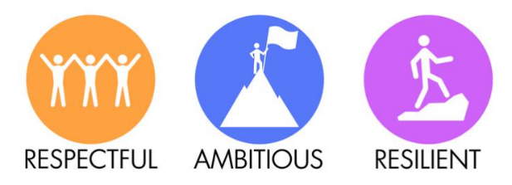
Wren Park Primary School
Whole-school long-term
Religious Education curriculum overview

Build knowledge about: | Autumn 1 | Autumn 2 | Spring 1 | Spring 2 | Summer 1 | Summer 2
EYFS | Believing: Key Question F2:  Which people are special and why? | Expressing: Key Question F4:  Which times are special and why? | Believing: Key question F1:  Which stories are special and why? | Living: Key Question F5:  Where do we belong? | Expressing: Key question F3:  Which places are special and why? | Living: Key Question F6:  What is special about our world?
Year 1 | What does it mean to belong to a faith community? | Who is a Christian and what do they believe | Who is a Muslim and what do they believe? | How and why do we celebrate special and sacred times? | What makes some places special? | What makes some places special?
Year 2 | Who is a Jewish and what do they believe? | How and why do we celebrate special and sacred times? (Part 2) | Who is a Muslim and what do they believe? (Part 2) | Who is a Christian and what do they believe? (Part 2) | How can we learn from sacred books? | How should we care for others and the world and why does it matter?
Year 3 | What does it mean to be a Christian in Britain today? | What does it mean to be a Hindu in Britain today? | Why is the Bible so important for Christians today? | Why are festivals important to religious communities? | What do different people believe about God? | Why do people pray?
Year 4 | What does it mean to be a Hindu in Britain today? | What does it mean to be a Christian in Britain today? | Why are festivals important to religious communities? | Why is Jesus inspiring to some people? | What can we learn from religions about deciding what is right and wrong? | Why do some people think that life is like a journey and what significant experiences mark this?
Year 5 | Why do some people think God exists? | What does it mean to be a Muslim in Britain today? | What matters most to Christians and  Humanists? | What would Jesus do? (Can we live by the values of Jesus in the twenty-first  century?) | If God is everywhere, why go to a place of worship? | f God is everywhere, why go to a place of worship?
Year 6 | What does it mean to be a Muslim in Britain today? (Part 2 | What difference does it make to believe in Ahimsa, Grace and/or Ummah | Is it better to express your beliefs in arts and architecture or in charity and generosity. | Is it better to express your beliefs in arts and architecture or in charity and generosity. | What do religions say to us when life gets hard? | What do religions say to us when life gets hard?

