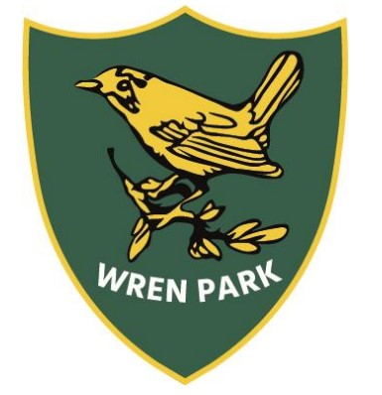
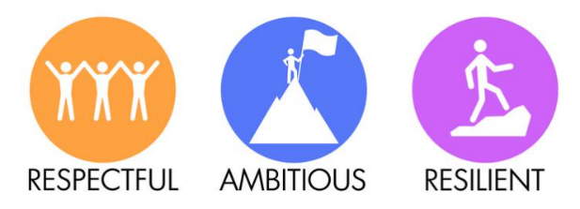
Wren Park Primary School
Year 2 Long Term Plan

Trips
Autumn 1 – Tamworth Castle Summer 2 – Farm Trip
 | Autumn 1 | Autumn 2 | Spring 1 | Spring 2 | Summer 1 | Summer 2
Topic | Would you rather live in a castle or a palace? | What made the Great Fire of London ‘Great’? | What makes someone a Superhero? | What came first – the seed or the plant? | Which is the best continent to live on? | Who likes to live beside the seaside?
English | Narratives: The Paper Bag Princess and The Princess and the Pea  Non-Chronological Report: Castles  Poetry: Autumn - Descriptive | Narratives: The Snowman and Vlad & the GFoL  Biography Lilian Bader (WW2)  Diary Entry: Samuel Pepys diary entry  Poetry: Fireworks/Christmas | Narratives: Traction Man and The Owl who was Afraid of the Dark  Letter: Florence Nightingale | Narrative: The Extraordinary Gardener  Instructions: How to grow a plant  Poetry:  Mother’s Day Kenning poem  Easter poem | Narratives: The Pirate’s Next Door and The Night Pirates  Non-fiction: Animal Riddle  Non-fiction: Continents Fact file  Poetry: Pirates | Narrative: The Lighthouse Keeper’s Lunch  Non-fiction: Postcard  Poetry: Seaside
Maths | Number and Place Value  Shape | Addition and Subtraction  Multiplication and Division | Multiplication and Division  Fractions | Money  Length and Height  Y2 Objectives Revision | Measurement: capacity, mass and temperature  Time  Consolidation | Statistics  Geometry: Position and direction  Consolidation
Science | Materials  Working scientifically | Animals and their habitats | Animals including humans | Plants | Animals and their world habitats | Animals including humans 2 Lifecycles  Trip: Farm
History and  Geography | Castles  Maps and symbols  Trip: Tamworth Castle | The Great Fire of London | Significant Individuals: Florence Nightingale, Edith Cavell and Mary Seacole  Compare Derby and Jamaica  Superheroes Day | Human and physical features of the school’s surrounding areas | Continents and oceans  Pirate Day | Seaside’s now and then
Computing | Computing systems and networks. Information Technology around us | Creating Media: Digital Writing | Programming:  Robot Algorithms | Data and information:  Pictograms | Creating Media: Making music | Programming: Programming quizzes
RE | Who is Jewish and what do they believe? | How and why do we celebrate special and sacred times? (Part 2) | Who is a Muslim and what do they believe? (Part 2) | Who is a Christian and what do they believe? (Part 2) | How can we learn from sacred books? | How should we care for others and the world and why does it matter?
Art | Drawing: Autumn sketching | Painting and mixed media: Life in colour | Sculpture and 3D clay houses |  | Craft and design – Map it out | Seaside drawing and painting
DT | Structures: Knight’s chair | Textiles: Christmas stocking |  | Mechanisms: Make a moving monster |  | Mechanisms: Fairground ride  Cooking: Make a healthy sandwich
PSHE/  British Values | Being me in my world  Democracy | Celebrating differences  Rule of Law | Dreams and goals  Individual Liberty | Healthy me  Mutual Respect, Tolerance and Diversity | Relationships  Consolidation of British Values | Changing me  Consolidation of British Values
PE | Outdoor: Multi Skills – Throwing and Catching  Indoor: Games – Circuit training | Outdoor: Invasion Games  Indoor: Dance – The Great Fire of London | Outdoor: Attacking and defending  Indoor: Gymnastics – Movement  25/26 Dance - superheroes | Outdoor: Multi sports – Bat and Ball  Indoor: Dance – Plants | Outdoor: Target Games  Indoor: Gymnastics – Landscapes and cities | Outdoor: Animal olympics  Indoor: Gymnastics – Under the sea
Music | Harvest Assembly Songs | Playing in an Orchestra  Christmas songs | Inventing a Musical Story | Recognising Different Sounds | Exploring Improvisation | Our Big Concert

