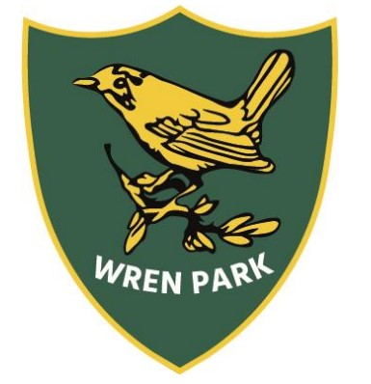

Wren Park Primary School
Writing long term plan
Year 2

 | Autumn 1 | Autumn 2  Assessment Week - Recount | Spring 1 | Spring 2  Assessment Week - Instructions | Summer 1 | Summer 2  Assessment Week - Narrative
 | Would you rather live in a castle or a palace? | What made the Great Fire of London ‘Great’? | What makes someone a Superhero? | What came first – the seed or the plant? | Which is the best continent to live on? | Who likes to live beside the seaside?
Class text linked to curriculum topic) | Fiction:  The Pea and the Princess  Mini Grey  The paper bag Princess  Robert Munch | Non-fiction texts  Vlad the Flea  Great Fire of London Texts  The Snowman  Raymond Briggs | Fiction:  Traction Man  The Owl who was afraid of the dark  Non-Fiction:  Florence Nightingale | Fiction:  The extraordinary gardener  Non-Fiction:  What plants need  Lifecycle of a bean | Fiction:  The pirates next door  The night pirates  Non-Fiction:  World continents  Real-life/ Famous pirates | Fiction  Flotsom  The Lighthouse Keeper’s Lunch  Non-fiction  Seaside then and now information books
Writing units (taught in English lessons) | Writing to Entertain:  Retelling a story  Inventing a story in the style of…The paper bag Princess  Writing to inform:  Tamworth Castle recount  Castles information text  Poetry:  Autumn Descriptive Poems | Writing to Entertain:  Diary entry for the Great Fire of London  Lilian Bader biography  Writing to Inform:  Recount  Snowman instructions  Verbalising a sentence | Writing to Entertain:  Retelling a story  Inventing a story in the style of…Traction Man  Adding a chapter to The Owl who was afraid of the Dark  Writing to Inform:  Recount  Explanation Text:  Florence Nightingale letter | Writing to Entertain:  Retelling a story  Inventing a story in the style of…The Extraordinary Gardener  Writing to Inform  Recount  Plant instructions  Poetry:  Mothers Day Kenning Poems | Writing to Entertain:  Retelling a story  Inventing a story in the style of…The Pirates Next Door  Writing to Inform  Recount  Non-chronological report about Continents. | Writing to Entertain:  Retelling a story  Inventing a story in the style of…The Lighthouse Keeper’s Lunch  Writing to Inform  Recount  Seaside postcard  Seaside information poster/leaflet  Poetry:  Seaside rhyming poems

