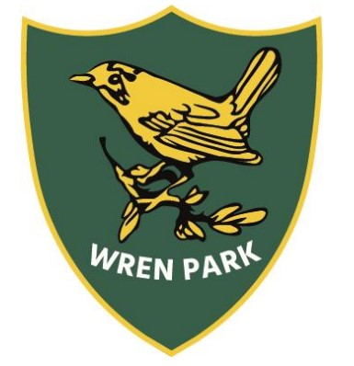
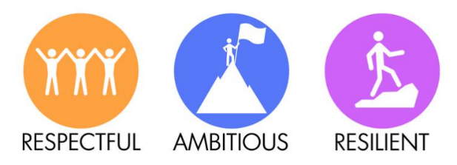
Wren Park Primary School
Reading long term plan
Year 2

 | Autumn 1 | Autumn 2 | Spring 1 | Spring 2 | Summer 1 | Summer 2
Topic | Would you rather live in a castle or a palace? | What made the Great Fire of London ‘Great’? | What makes someone a Superhero? (Significant people) | What came first – the seed or the plant? | Which is the best continent to live on? | Who likes to live beside the seaside?
Core Teaching Texts for VIPERS | Fiction:  The Pea and the Princess  Mini Grey  The paper bag Princess  Robert Munch | Non-fiction texts  Vlad the Flea  Great Fire of London Texts  The Snowman  Raymond Briggs | Fiction:  Traction Man  The Owl who was Afraid of the Dark  Non-Fiction:  Florence Nightingale  Owls | Fiction:  The extraordinary gardener  Jim and the beanstalk  Non-Fiction:  What plants need  Lifecycle of a bean | Fiction:  The pirates next door  The night pirates  Non-Fiction:  World continents  Real-life/ Famous pirates | Fiction  Flotsom  The Lighthouse Keeper’s Lunch  Non-fiction  Seaside then and now information books
VIPERS  Main focus reading skills  (all other VIPERS skills to be covered across the half term at least twice) | Vocabulary  Inference  Prediction | Vocabulary  Inference  Retrieval | Vocabulary  Inference  Explaining | Vocabulary  Inference  Sequencing | Vocabulary  Inference  Prediction | Vocabulary  Inference  Explaining
Themes linked to Personal Development  British Values  Protected Characteristics  UN Rights of the Child | The paper bag Princess  Robert Munch  British Value: Individual Liberty – Encourages empowerment and the freedom to make one's own choices, as the princess defies traditional expectations.  Protected Characteristic: Sex (Gender) – Challenges traditional gender roles, with the princess taking charge and showing strength and intelligence.  UNCRC Right: Article 12 (Respect for the Views of the Child) – Highlights the princess’s right to make her own decisions and assert her independence. | Vlad the Flea  British Value: Mutual Respect and Tolerance – Promotes acceptance and understanding despite differences, as Vlad and the other characters learn to work together.  Protected Characteristic: Age – Demonstrates that even the smallest, seemingly least significant individuals can have an important impact, regardless of age or size.  UNCRC Right: Article 2 (Non-Discrimination) – Emphasizes that all children, regardless of their background or appearance, deserve to be treated with respect and dignity. | The Owl who was afraid of the Dark  British Value: Mutual Respect and Tolerance – Encourages understanding and acceptance of differences, as the owl learns to overcome fear with the help of others.  Protected Characteristic: Age – Focuses on the developmental journey of overcoming childhood fears and building confidence.  UNCRC Right: Article 12 (Respect for the Views of the Child) – Highlights the owl’s right to express feelings and be supported in overcoming fears. | The extraordinary gardener  British Value: Mutual Respect and Tolerance – Promotes understanding and respect for individual differences and the value of community collaboration.  Protected Characteristic: Disability – Focuses on inclusivity, as the main character brings beauty and life to a community despite facing personal challenges.  UNCRC Right: Article 31 (Right to Play and Leisure) – Highlights the importance of creativity and the joy of gardening as a form of self-expression and recreation. | The pirates next door  British Value: Mutual Respect and Tolerance – Promotes acceptance of differences and the value of diversity as the community learns to embrace the pirates.  Protected Characteristic: Race – Explores themes of cultural diversity and the importance of accepting people who are different.  UNCRC Right: Article 2 (Non-Discrimination) – Emphasizes that all children, regardless of their background or appearance, have the right to be treated equally. | The Lighthouse Keeper’s Lunch  British Value: Individual Liberty – Encourages problem-solving and independence, as the lighthouse keeper creatively resolves his lunch delivery issue.  Protected Characteristic: Age – Reflects the kindness and cooperation between the elderly lighthouse keeper and the younger characters, showing respect across generations.  UNCRC Right: Article 24 (Health and Health Services) – Highlights the importance of good nutrition and taking care of one's health, as the lighthouse keeper needs his lunch for sustenance.
Poetry  (1 week for Vipers) | Descriptive Autumn poems | Firework poems | Acrostic poem | Easter poems  Kenning poem | Pirate poems  Rhyming couplets | Seaside Poems
Read for pleasure | Alternative traditional tales  Gobbolino  Ursula Williams  Julia Donaldson stories  Library books | Oliver Jeffers  Christmas stories  Library books | The Enchanted Wood  The Magic Faraway tree  Library books | Dick King-Smith  Ann Fine  Library books | Pirate stories  Library books | Seaside stories  Library books
Knowledge | In Year 2, most children are well on the way to becoming fluent readers. They will be given opportunities to develop their understanding of books they read and books that are read to them. Children will learn to:  - Use phonics to decode complex words  - Blend and recognise alternative sounds for graphemes  - Read words that use common suffixes  - Read more common exception words (tricky words)  - Read most words quickly and accurately  - Read some books out loud  - Re-read books to build up fluency and confidence  - Listen to and talk about a range of stories and texts  - Understand the books they read and listen to  Talk about books and poems, taking turns and listening to what others say.
Vocabulary | Phonics, sounding out, blending, picture clues, VIPERS, vocabulary, inference, prediction, explanation, retrieval, summarise, reading skills, comprehension, fluency, expression, punctuation, reading for pleasure, library, phoneme, grapheme, author, blurb, illustrator, punctuation, fiction, non-fiction

