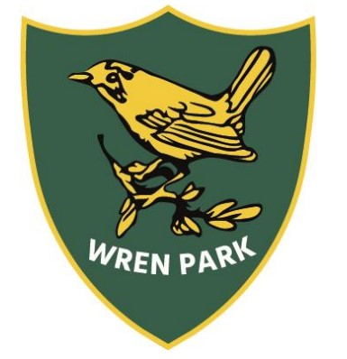
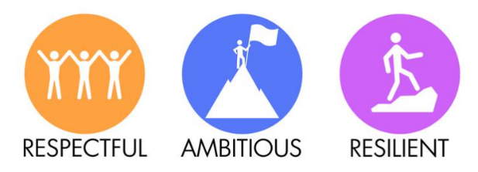
Wren Park Primary School
Reading long term plan
Year 3

 | Autumn 1 | Autumn 2 | Spring 1 | Spring 2 | Summer 1 | Summer 2
Topic | The Stone Age |  | Romans in Britain |  | Rainforests and Explorers
Core Teaching Texts for VIPERS | Fiction  Stone Age Boy  Non-Fiction  The Street Beneath my Feet.  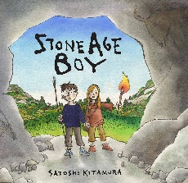 | Non Fiction  The Pebble in my Pocket | Fiction  Down with the Romans  Non Fiction  The Roman Soldier Handbook | Fiction  Down with the Romans | Fiction  The explorer  Katherine Rundall  Non-Fiction  Layers of the Rainforest.  A is for Anaconda: A rainforest Alphabet | Fiction  The explorer  Katherine Rundall  Non Fiction  Rainforest animals
VIPERS  Main focus reading skills  (all other VIPERS skills to be covered across the half term at least twice) | Vocabulary  Inference  Summarise | Vocabulary  Explanation  Retrieval. | Vocabulary  Inference  Explanation | Vocabulary  Inference  Retrieval | Vocab  Inference  Summarise | Vocabulary  Explanation  Prediction
Poetry  (1 week for Vipers) | I was Born in the Stone Age - Michael Rosen. | VE Day poem.  Kennings Poetry  Winter Poems | Humorous Poems | Traditional Poems by  Robert Louis Stevenson | Shape poems | Performance poetry
Read for pleasure | The Wild Robot | Billy and the Minpins | The Midnight Gang | Mr Stink | Kensuke’s Kingdom | The Night Bus Hero  .
Themes linked to Personal Development  British Values  Protected Characteristics  UN Rights of the Child | British Value: Mutual Respect and Tolerance – Highlights the importance of understanding and coexisting with others, even those who are different.  Protected Characteristic: Disability – Roz, the robot, adapts to challenges and learns to thrive despite limitations, reflecting themes of resilience and inclusion.  UNCRC Right: Article 27 (Adequate Standard of Living) – Emphasizes the right to a safe and supportive environment, as Roz creates a nurturing home for herself and others. | British Value: Individual Liberty – Encourages curiosity, bravery, and independent thinking.  Protected Characteristic: Age – Highlights how children, like Billy, are capable of great courage and intelligence despite their young age.  UNCRC Right: Article 31 (Right to Play and Leisure) – Emphasizes a child's right to imagination, adventure, and exploring the world. | British Value: Mutual Respect and Tolerance – Shows kindness, friendship, and acceptance among children with different backgrounds and challenges.  Protected Characteristic: Disability – Highlights the experiences of children in a hospital, promoting inclusion and understanding.  UNCRC Right: Article 24 (Health and Health Services) – Emphasizes every child's right to medical care and a supportive environment. | British Value: Individual Liberty – Encourages kindness, standing up for others, and making independent moral choices.  Protected Characteristic: Disability – Suggests themes of mental health and homelessness, promoting understanding and support.  UNCRC Right: Article 27 (Adequate Standard of Living) – Highlights every child’s right to a safe home and a good quality of life. | British Value: Mutual Respect and Tolerance – Shows the importance of understanding and respecting different cultures and ways of life.  Protected Characteristic: Race – Highlights Kensuke’s Japanese heritage and the value of cultural appreciation.  UNCRC Right: Article 9 (Separation from Parents) – Explores the challenges of being separated from family and the right to stay connected. | British Value: Mutual Respect and Tolerance – Highlights the importance of understanding, empathy, and breaking down prejudices.  Protected Characteristic: Race – Explores themes of diversity and overcoming racial stereotypes through the characters’ experiences.  UNCRC Right: Article 2 (Non-Discrimination) – Emphasizes the right of all children to be treated equally, regardless of their background or appearance.
Knowledge | In Year 3, the focus shifts from word-reading to comprehension and building the habits that make a confident and keen reader. Children will learn to:  - Understand root words, prefixes, and suffixes  - Read more common exception words (tricky words)  - Read a wide range of books and retell stories orally  - Read aloud, perform poems and play scripts  - Talk about interesting words and phrases  - Check that the text makes sense to them  - Read between the lines and use evidence from the text when giving their opinion  - Predict what might happen next  - Talk about books and poems  Use dictionaries to check the meaning of words
Vocabulary | Vocabulary, inference, prediction, explanation, retrieval, summarise, reading skills, comprehension, expression, punctuation, reading for pleasure, library, author, blurb, illustrator, punctuation, fiction, non-fiction, dictionary, root words, prefixes, suffixes, poetry, performance, play scripts, evidence

