

Wren Park Primary School
Reading Long Term plan
Year 5

 | Autumn 1 | Autumn 2 | Spring 1 | Spring 2 | Summer 1 | Summer 2
Topic | To Infinity and Beyond! | The Groovy Greeks | Our changing world | Smashing Saxons and Vicious Vikings | London calling! | How’s it growing?
Core Teaching Texts for VIPERS | Class animal work.  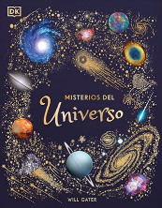  Non-fiction texts linked to topic:  Including biographies about women in space. | 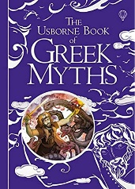  Greek myths: | Non- fiction texts linked to topic.  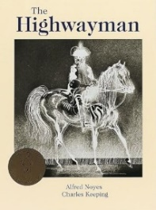  The Highwayman by Alfred Noyes:  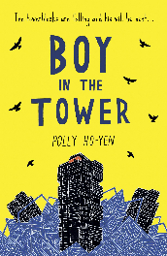  Boy in the Tower by Polly Ho-Yen: | 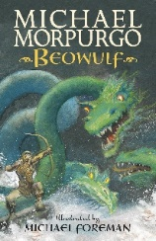  Beowulf – Anglo Saxon poem by Michael Morpurgo:  Boy in the Tower by Polly Ho-Yen: | 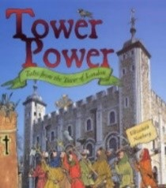  Tower Power: Tales from the Tower of London by Elizabeth Newbery:  Boy in the Tower by Polly Ho-Yen: | Non- fiction texts linked to topic.  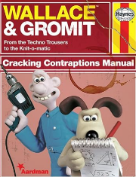  Stand alone lesson: Wallace & Gromit Cracking Contraptions Manual:
VIPERS  Main focus reading skills  (all other VIPERS skills to be covered across the half term at least twice) | Vocabulary  Retrieval  Summarise | Vocabulary  Retrieval  Summarise | Vocabulary  Prediction  Inference | Vocabulary  Prediction  Explain | Vocabulary  Inference  Explain | Vocabulary  Inference  Retrieval
Poetry  (1 week for Vipers) | Space poems:  Song in Space, by Adrian Mitchell.  Poem: Six ways to look at the moon – Pie Corbett | Poetry versions of myths. | The Highwayman by Alfred Noyes | Beowulf – Anglo Saxon poem by Michael Morpurgo | The British - Benjamin Zephaniah (links to diversity and Britain) | There's a Rang-Tan in My Bedroom- James Sellick
Read for pleasure | Wonder- R. J. Palacio | Wonder- R. J. Palacio | Jaz Santos vs The World- Priscilla Mante | Jaz Santos vs The World- Priscilla Mante | The Last Bear- Hannah Gold & Levi Pinfold | The Last Bear- Hannah Gold & Levi Pinfold
Themes linked to Personal Development  British Values  Protected Characteristics  UN Rights of the Child | British Value: Mutual Respect and Tolerance – Promotes understanding and acceptance of differences.  Protected Characteristic: Disability – Highlights the importance of fair treatment and inclusion.  UNCRC Right: Article 23 (Children with Disabilities) – Emphasizes dignity, support, and equal opportunities. | British Value: Mutual Respect and Tolerance – Promotes understanding and acceptance of differences.  Protected Characteristic: Disability – Highlights the importance of fair treatment and inclusion.  UNCRC Right: Article 23 (Children with Disabilities) – Emphasizes dignity, support, and equal opportunities. | British Value: Democracy – Shows the importance of having a voice and working together as a team.  Protected Characteristic: Race – Highlights diversity and challenges stereotypes.  UNCRC Right: Article 15 (Freedom of Association) – Emphasizes the right to form and join groups, like Jaz’s football team. | British Value: Democracy – Shows the importance of having a voice and working together as a team.  Protected Characteristic: Race – Highlights diversity and challenges stereotypes.  UNCRC Right: Article 15 (Freedom of Association) – Emphasizes the right to form and join groups, like Jaz’s football team. | British Value: Individual Liberty – Shows April’s courage to make her own choices and take action.  Protected Characteristic: Sex (Gender) – April, a young girl, defies gender stereotypes by showing bravery, independence, and a strong connection to nature in a traditionally male-dominated field (exploration and science). UNCRC Right: Article 29 (Education for Sustainability) – Emphasizes learning about and caring for the environment. | British Value: Individual Liberty – Shows April’s courage to make her own choices and take action.  Protected Characteristic: Sex (Gender) – April, a young girl, defies gender stereotypes by showing bravery, independence, and a strong connection to nature in a traditionally male-dominated field (exploration and science). UNCRC Right: Article 29 (Education for Sustainability) – Emphasizes learning about and caring for the environment.
Knowledge | In Year 5, Children will continue to develop their comprehension skills and build the habits that make a confident and enthusiastic reader. Children will learn to:  - Understand root words, prefixes, and suffixes  - Read and talk about a wide range of fiction, poetry, plays, non-fiction and reference books  - Recommend books to friends, giving reasons for their choices  - Talk about and compare themes in books  - Learn a range of poetry by heart and read poems and playscripts aloud with expression  - Check that the text makes sense to them  - Read between the lines and use evidence from the text to justify thinking  - Predict what might happen next  - Identify how the language, structure, and presentation of a text adds to its meaning  - Talk about how authors use language  - Tell the difference between fact and opinion  - Talk about books, building on their own and others' ideas  Talk about what they have read in presentations and debates
Vocabulary | Vocabulary, inference, complex inference, prediction, explanation, retrieval, summarise, reading skills, comprehension, expression, punctuation, reading for pleasure, discuss, fiction, non-fiction, record, language, recommend, character, setting, imagination, retell, dictionary, root words, prefixes, suffixes, poetry, performance, play scripts, evidence, feelings, synonym, antonym, word classifications, noun, pronoun, verb, adverb, adjective, preposition, fact, opinion

